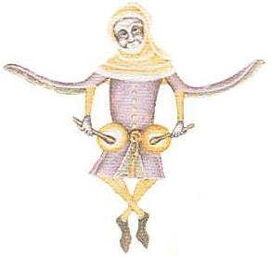
Lions and Wolves and Dancers..Oh My!
The Lilies XV Ball
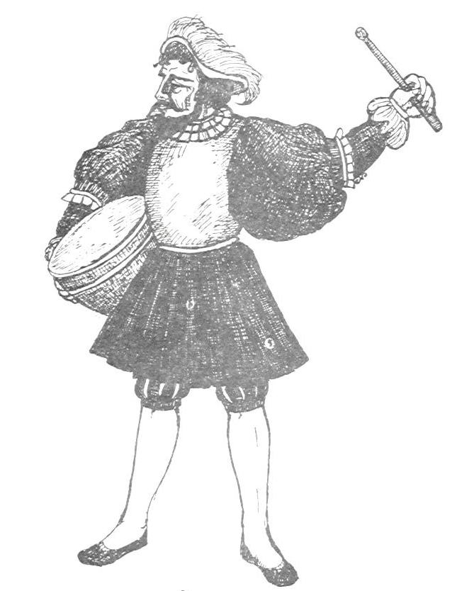
Gelosia (Domenico 1450)
(Line of 3 couples) == In 4 ==
8 Saltarelli 8
M1 3 piva passing in front of W1, ending at R of W2 3
Reverance while touching W1’s R hand ½
M2 Salatrello R to join W1 1
M1 3 piva circling in front of W2 going CCW most of the way 3
Around her , ending at R of W3
M1 reverance while touching W3’s R hand ½
M3 Saltarello R to join W2 1
M1 Saltarello R behind W3, ending to her left 1
8 Pive, holding hands with new partner 8

Couple 1 Mezzavolta in 1 piva away from each other 1
Couple 2 the same 1
Couple 3 the same, and all men Mezzavolta, in a R piva, ccw 1
Take R hands with partner, exchange places in Single L, R, L 1 ½
Take L hands, exchange back in Single R, L, R, men ending with
Mezzavolta R 1 ½
Repeat dance 2 times, until each man returns to original place
Sellinger’s Round (Playford 1670)
(Couples in a circle) == In 4 ==
Verse 1 Slide left; slide right 2; 2
Chorus Men back up a double while women go forward and clap 1
Return to place 1
(facing partner) Set & turn single 2
Women back up a double while men go forward and clap 1
Return to place 1
(facing partner) Set & turn single 2
Verse 2 Double in and out (2x) 2 (2x)
Repeat Chorus 8
Verse 3 Side right with your partner; Side left with your partner 2; 2
Repeat Chorus 8
Verse 4 Arm right with your partner; Arm left with your partner 2; 2
Repeat Chorus
Horses’ (1589)
(Double circle with ladies on inside or line) == In 4 ==
[4x] - Double left; Double right 1; 1 [4x]
* - Lords (right foot) paw, paw, step right; circle to the left (ccw) 1; 1
* - Ladies (right foot) paw, paw, step right; circle to the left (ccw) 1; 1
* Note: These sections may repeat depending on music.
Road to the Isles (SCA Choreography)
(Couples) == in 4 ==
Point left foot
Step behind (with left), to the side (with right), cross forward (with left), point right foot
Step behind (with right), to the side (with left), cross forward (with right), point left foot
Step back (with left)
Step LRL and hop; Step RLR hop & turn; Step LRL, hop & turn; Back RLR and hop
Step LRL, hop & turn; Back RLR and hop; Step LRL, hop & turn; Back RLR and hop
Man walks forward with lady turning under right arm
Come together, apart, and move back into original position
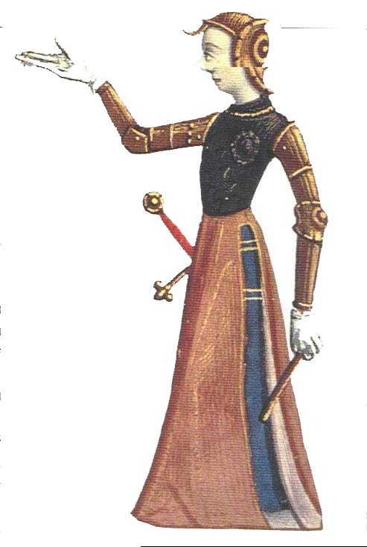

Set 1 –

Gathering Peascods
Black Alamande
Petit Vriens
Grimstock
Queen’s Alamande
Candlestick Bransle
Official Bransle

Set 2 –

Quen Quer Que
Lorayne Allamande
Picking of Sticks
Amoroso
Goddesses
Rostiboli Goioso
Dashing White Sergeant

Quen Quer Que (SCA to 13th c. Cantiga)
(as many as will in a circle)

Chorus: (2x)
with circle rotating to the Left;
L Double moving into circle,
R double moving out
Single L, Single R, Double L, Single R
Verse: (4x)
L Double, R double
Single L, Single R, Double L, Single R
(1st – as written, 2nd – turn on 1st double left
3rd – turn on 2nd double left, 4th – turn on both double lefts)

Lorayne Alman (1570)
(Couples in a line) == in 4 ==
4 doubles forward; beginning with left 4
[2x] - Double left forward; Double right back; 1; 1
Double left forward; Double right circling away 1; 1 (2x)
Picking of Sticks (Playford 1651)
(3 couples in a line) == In 4 ==
Verse 1 Forward and back a double (2x)
Chorus 1 Top L person switches back to back with 2nd R person, then 3rd L person
All forward and back a double
Top R person switches back to back with 2nd L person, then 3rd R person
All forward and back a double
Repeat above until back to place
Verse 2 Side right with your partner; Side left with your partner
Chorus 2 C1 slips between C2 as they move up, then C2 slips between
Couple 1 (2x); meanwhile, couple 3 crosses and skips around couple 1 & 2
Repeat above with couples 2 & 3 slipping while couple 1 skips around
Verse 3 Arm right with your partner; Arm left with your partner
Chorus 3 Sheepskin Hey - Men weave through ladies; as last man passes
second lady, he cuts around to take the lead; Each man cuts once,
and then pass behind the ladies and back to place
Repeat above with ladies weaving between men
Amoroso (Ebreo)
(Couples) == In 4 ==
8 doubles
Lord: single, single, ornamented double, 3 strutting singles
Lady: same to catch up
Lord: 4 doubles; Lady: same to catch up
Lord: single, single, ornamented double; Lady: same to catch up
2 ct reverence
4 doubles
Note: This dance is to show off your dancing technique. Where it says double do any kind of double you want. Also most people seem to like changing the last Lord, Lady exchange into a heart pattern creation with both doing the steps each time.
Goddesses (Playford 1651)
(4 couples in a line) == In 4 ==
Verse 1 Forward & back a double (2x) 2 (2x)
Chorus Couple 1 cast away from each other & lead down to bottom of set as
Others follow; meet partner & cast off from bottom of set back to place 2;2
Verse 2 Take hands along own side; Man 1 lead men around, ending behind
Lady 3’s position as Lady 1 leads ladies around ending in front of
Man 3’s position (½ circle with ladies on inside); Man 3 & Lady 3
Lead lines back to orginal place 2;2
Repeat Chorus
Verse 3 Men take hands in circle of 4, as ladies do same & circle L; then R 2;2
Repeat Chorus 2;2
Verse 4 Take hands in 1 circle of 8 & circle L; then circle R 2;2
Repeat Chorus 2;2
Verse 5 Men do a Hey for 4 while Ladies do a Hey for 4 (1 & 3 face down, 2 &
4 face up. Begin passing R shoulders & alternate til all back to place) 4
Repeat Chorus 2;2
Verse 6 Hey through entire set. (Begin as before, but when get to the end of the
Line, instead of curving all the way around, cross to the other line. Each
Dancer follows another dancer all the way around the circle) 4
Repeat Chorus 2;2
(Note: if your version of the music has more verses, V1 is the same, V2 is the men
going behind the ladies & back; V3 is the ladies going behind the men & back; V4
is men circling the ladies; V5 is ladies circling the men; V 6 is men’s circle; V 7 is lady’s
circle; V 8 is circle for all, V9 is men’s hey; V 10 is ladies hey; V11 is hey for all)
Rosti Boli Gioioso (Domenico 1450)
(Couples) == In 6 ==
Intro Reverance 1
Part 1 Reprise left and right (together) 2
(Lord) Single left; Single right; 2 Doubles (beginning left) away ½; ½; 2
Reprise left and right (Lord turning around) 2
(Lord) Single left, Single right, 2 Doubles (beginning left) returning ½; ½; 2
Repeat above with Lady going out and back 10
Part 2 Reprise left and right; 2 Singles; 3 Doubles; VdG (2x) 2; 1; 3; 2 (2x)
Part 3 16 Salterelli (hop on upbeat) 16
Part 4 Movimenti (Lord then Lady); (Lord) Double left away 1; 1
Movimenti (Lady then Lord); (Lady) Double left to join Lord 1; 1
Movimenti (Lord then Lady); (Lord) Double left away 1; 1
Movimenti (Lady then Lord); (Lady) Double left to join Lord 1; 1
Repeat entire dance
Dashing White Sergeant (Oral Tradition)
(Sets of 3 people facing another set around a circle) == In 4 ==
All 6 take hands; Slide left; Slide right; (drop back to sets of 3) 2; 2
Center person faces person on R; Set R & L; (taking both hands) Turn full circle 1; 1
Center person faces person on L; Set R & L; (taking both hands) Turn full circle 1; 1
Reel for 3 - center person passes right shoulders with person on right,
and continues to weave until back in place 4
(taking hands and facing other set) Double forward and back 2
Double forward (x2), passing through other set 2

Candlestick Bransle (Arbeau)

(Couples ) ==in 4==
LORDS: with a candle in right hand
8 Doubles Forward starting w/ Left 8
In front of a lady - L Side Single, R side Single (2x) 2 (2x)
Take R hands
TOGETHER: 8 Doubles Forward starting w/ Left 8
Face partner
L Side Single, R side Single 2
Pass candle to lady’s right hand 2
Repeat with Ladies leading.

Queen’s Alman (1650 - 1700)
(Couples in a line) == in 4 ==
Double left forward; Double right backward (end facing partner) 1; 1
Step left, Step right, Circle LRL (end facing forward) 2
Double right forward; Double left backward (end facing partner) 1; 1
Step right, Step left, Circle RLR (end facing forward) 2
4 doubles forward [beginning with left] 4
Montard (1589)
(Line of 4 people side by side) == In 4 ==
8 singles left (leftmost person weaves through after first time) 4
1st person turns in 4 kicks; 2nd person turns in 4 kicks 1; 1
3rd person turns in 4 kicks; 4th person turns in 4 kicks 1; 1
Note: Counts can vary depending on music
Anello (Domenico 1450)
(2 couples facing) == In 4 ==
Introduction All join hands and circle left with 8 salterelli 8
Part 1 Movimenti [Lords then Ladies]; Lords switch places in 2 salterelli 1;2
Movimenti [Ladies then Lords]; Ladies switch places in 2 salterelli 1;2
Part 2 Movimenti [Lords then Ladies]; Lords turn single 1;1
Movimenti [Ladies then Lords]; Ladies turn single 1;1
Part 3 Lords cast out behind partner and switch places in 4 piva 2
Ladies cast out behind partner and switch places in 4 piva 2
Part 4 Movimenti [Lords then Ladies] 2x; Lords reprise; All reverenza 2;1;1
Repeat with Ladies leading
Mannschaft Pavan (SCA Choreography)
(4 couples in an improper line) == In 4 ==
Reverance 2
(towards head of the hall) Left pavanne set 2
(with partner) Palm left; Palm right; Palm left and switch places ½; ½; 1
Palm right; Palm left; Palm right and switch places ½; ½; 1
(towards back of the hall) Left pavanne set; Right pavanne set 2; 2
(with 2 couples) Ladies palm left ; Lords palm right; ½; ½
Ladies palm left and switch places 1
Lords palm right; Ladies palm left; ½; ½
Lords pa lm right and switch places 1
(towards head of the hall) Left pavanne set; Right pavanne set 2; 2
(with 4 couples) Ladies palm left ; Lords palm right; ½; ½
Ladies palm left and move forward one place 1
Lords palm right; Ladies palm left; ½; ½
Lords palm right and move forward one place 1
towards back of the hall) Left pavanne set; Right pavanne set 2; 2
(with 2 couples) Ladies palm left ; Lords palm right; ½; ½
Ladies palm left and switch places 1
Lords palm right; Ladies palm left; ½; ½
Lords palm right and switch places 1
(towards head of the hall) Left pavanne set; Right pavanne set 2; 2
(with partner) Palm left; Palm right; Palm left and switch places ½; ½; 1
Palm right; Palm left; Palm right and switch places ½; ½; 1
Reverance
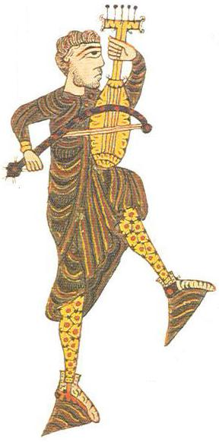
Official (1589)
(Circle of couples) == In 4 ==
[2x] - Double left; Double right 1; 1 [2x]
8 singles left, 4
on 7 and 8, lady leaps to other side of man, man assists
Note: The second section may repeat depending on music.

Heralds in Love
(4 couples in a line) == In 4 ==
Verse 1 Forward and back a double; set and turn single (2x) 2;2(2x)
Chorus 1 M1 & L2 exchange places with right hands, while M3 & L4 do likewise.
(In improper sets, this choruse is all men); M1 & L4 exchange
Places with left hands; L2 & 4 exchange with right hands while 1;1;1;1;
M1 & M3 do likewise, and so on until all back in their original places. 1;1;1;1;
Verse 2 Side right; Set & turn single; Side left; Set & turn single 2;2;2;2
Chorus 2 (In improper sets, this chorus is all women). L2 & M2 exchange
places with right hands; M1 & M3 exchange places with left hands
While L2 & L4 do likewise; M1 & L4 exchange places with right 1;1;1;1;
hands, and so on until all back in their orignal places. 1;1;1;1
Verse 3 Arm right; Set & turn single; Arm left; Set & turn single 2;2;2;2
Chorus 3 Do chorus 1 and chorus 2 together. In improper sets, men will always
Be exchanging places with men, and ladies with ladies. In proper sets
Each dancer should remember with which 3 other dancers he or she was
exchanging places. 1;1;1;1;1;1;1;1
Rufty Tufty (Playford 1651)
(2 couples facing) == In 4 ==
Verse 1 Forward and back a double (2x) 4
Chorus (facing partner) Set & turn single (2x) 4
Lead partner out a Double and back; Turn single 2; 1
Lead corner out a Double and back; Turn single 2; 1
Verse 2 Side right with your partner; Side left with your corner 2; 2
Repeat Chorus 10
Verse 3 Arm right with your partner; Arm left with your corner 2; 2
Repeat Chorus 10
Heart’s Ease (Playford 1651)
(2 couples facing) == In 4 ==
Verse 1 Forward and back a double (2x) 2 (2x)
Chorus (facing partner) Back away from partner and forward a double 2
Turn corner 2
(facing corner) Back away from corner and forward a double 2
Turn partner 2
Verse 2 Side right with your partner; Side left with your corner 2; 2
Repeat Chorus 8
Verse 3 Arm right with your partner; Arm left with your corner 2; 2
Repeat Chorus 8
Korobushka
(Couples facing ccw around a circle) == In 4 ==
Step R, R; Step L, L; Step R, L; Turn to face partner 1; 1; 1; 1
Spin away and clap; Spin back and clap (take hands) 1; 1
Come together & apart; switch sides 1; 1
Spin away and clap; Spin back and clap (take hands) 1; 1
Come together & apart, and back into original position 1; 1
Gathering Peascods (Playford 1651)
(4 - 7 couples in a circle) == In 4 ==
Verse 1 Slide L (8 counts); Turn single; Slide R (8 counts); Turn single 2;1;2;1
Chorus 1 Men couble in and circle (12 counts); Ladies do same 3;3
Men in & clap; Ladies in & clap (M out); 1;1
Men in & don’t clap (L out) & turn to place 2
Ladies in & clap; Men in & clap (L out); 1;1
Ladies in & don’t clap (M out) and turn to place 2
Verse 2 Side R with partner; Turn single; Side L with partner; Turn single 2;1;2;1
Chorus 2 Same as chorus 1, except Ladies do everything first 14
Verse 3 Arm R with partner; Turn single; Arm L with partner; Turn single 2;1;2;1
Chorus 3 Same as chorus 1 14
Black Alman (1650 - 1700)
(Couples in a line) == in 4 ==
4 alman doubles, beginning with left [end facing partner] 4
Left double backing away from partner; Right double toward partner 1; 1
[turn to own left] Left double away from partner 1
[turn around] Right double toward partner 1
Lords step L, step R; circle LRL; Ladies step L, step R; circle LRL 1; 1; 1; 1
[take hands with partner] Left double switching places; 4 slides up the hall 1; 1
Left double switching places; 4 slides down the hall 1; 1
Left double backing away from partner; Right double toward partner 1; 1
Petit Vriens (Ebreo 1470)
(Set of 3 people) == In 6 ==
16 Piva 8
Then A 4 Piv; then B 4 Piv to catch up to A; then C 4 Piv to catch up 4; 4; 4
(musically in 6) == In 4 to dance ==
A DL; then B DL; then C DL 1; 1; 1
A Rev (short, only half bar) to B; then B same to A ½; ½
C Rev (short) to B; B Rev back; All Rev (normal) ½; ½; 1
DL backwards, fanning out (ie A bit to L, C bit R) 1
DR forward back to place 1
RipL; RipR; VT (DL going counter clockwise) ½; ½; 1

Grimstock (Playford 1651)
(3 couples in a line) == In 4 ==
Verse 1 Forward and back a double; Set & turn single (2x) 2;2 (2x)
Chorus 1 Switching - 4
Couple 1 goes in between couple 2 and outside of couple 3
Couple 2 goes in & out; Couple 3 goes in & out (back to place)
Verse 2 Side right; Set & turn turn single; Side left; Set & turn turn single 2; 2; 2; 2
Chorus 2 Arches - 4
Couple 1 goes under couple 2’s arch & arches over couple 3
Couple 2 goes under & over; Couple 3 goes under & over (back to place)
Verse 3 Arm right with your partner; Set & turn single 2; 2
Arm left with your partner; Set & turn single 2; 2
Chorus 3 Crossover Hey - 4
Couple 1 cross over & Hey down the set (on partner’s side)
Couple 1 crosses back at bottom of set & Hey up the set (on own side)
Female Sailor (Recueil de Contradances 1706)
(Couples in a line) ==In 4==
(A) Up through line, around outside, and back to place 2
(A) Down through line, around outside, and back to place 2
(A) Cross over and down through line, around outside, and into partner’s place 2
(A) (taking both hands) Turn full circle 2
(A with I) (A facing down the set, I facing up) Do-Si-Do 2
(taking both hands) Turn full circle 2
All with partner Do-Si-Do 2
(A) (taking both hands) turn half circle, cast off and move down the set 2
At the same time (I) (taking both hands) turn full circle, moving up the set
Jenny Pluck Pears (Playford 1651)
(3 couples in a circle) == In 4 ==
Verse 1 Slide left; Set & turn single; Slide right; Set & turn single 2; 2; 2; 2
Chorus 1 First Lord turns Lady into center; Second Lord does same 1; 1
Third Lord does same; All reverance 1; 1
Lords skip around left; then right 4; 4
First Lord turns lady back to place; Second man does same 1; 1
Third man does same; All reverance 1; 1
Verse 2 Side right; Set & turn turn single; Side left; Set & turn turn single 2; 2; 2; 2
Chorus 2 Same as chorus 1, except Ladies turn men in and skip around 16
Verse 3 Arm right; Set & turn turn single; Arm left; Set & turn turn single 2; 2; 2; 2
Chorus 3 Same as chorus 1 16

Earl of Salisbury Pavanne (Ornamented Quadran Pavanne 1570)
(Couples in a line) == In 4 ==
Left pavanne set forward 2
Bransle [apart & together]; Right double backward 1; 1
Left pavanne set forward [end facing with hands joined] 2
Bransle [up the line & back]; Right double backward [away from partner] 1; 1
Left pavanne set forward 2
[toward partner, pass right shoulders, end back to back]
Right and left single [turning to face partner]; Right double backward 1; 1
Left pavanne set forward [join both hands and turn, switching places] 2
Bransle [up the line & back, then face front]; Right double backward 1; 1
Set 3 –

Montard Bransle
Anello
Maanschaft Pavan
Heralds in Love
Rufty tufty
Heart’s Ease
Korobushka

Set 4 –

Female Sailor
Jenny Pluck Pears
Earl of Salisbury Pavan
Gelosia
Sellengers Round
Horses Bransle
Road to the Isles

